Union VMS - Modules
Those diagram explain the communication between modules and their activity. They are meant to evolve with the progressive replacement of JMS by REST and the development of new functionalities, starting with Subscription.
Subscription module is used only as skeleton foe the future development, always saying yes to reports or no to queries.

Fishing Activity
Four activities to develop:
- Incoming FA Report → Outgoing FA Response
- Incoming FA Response
- Incoming FA Report → Outgoing FA Report (Subscription)
- Incoming FA Query → Outgoing FA Report (Subscription)
Beside JSM, SOAP webservice to the TL Bridge can be implemented:
- (1.1) OUTGOING MESSAGE: FMC receives message: FMC must implement BRIDGE-CONNECTOR wsdl (TL invokes it)
- (3.3) TL INCOMING MESSAGE: FMC sends message: FMC must invoke CONNECTOR-BRIDGE wsdl (TL implements it)
# | Activity | Queue | Producer | Consumer
0 | TRANSMIT
0.1 | MS transfer message to the central node | N/A
1 | RECEIVE
1.1 | TL transfer report | UVMSFAPluginEvent | TL | Plugin
1.2 | Plugin transfer report | UVMSExchangeEvent | Plugin | Exchange
1.3 | Exchange logs and transfer report | UVMSRulesEvent | Exchange | Rules
2 | VALIDATE
2.1 | Rules enrich report for validation (synchronous) | UVMSMdrEvent  UVMSRules | Rules  MDR | MDR  Rules
2.2 | Rules enrich report for validation (synchronous) | UVMSAssetEvent  UVMSRules | Rules  Asset | Asset  Rules
2.3 | Rules check authorization via Activity  (authorization loop) | UVMSActivityEvent | Rules | Activity
2.4 | Activity translate message to a subscription (authorization) request | UVMSSubscriptionEvent | Activity | Subscription
2.5 | Subscription sends authorization response  On v.1.3.10 Subscription authorization is always true to receive report and false to FA Query | UVMSRules | Subscription | Rules
3 | RESPOND
3.1 | Rules send response (selector for shared queue) | UVMSExchangeEvent | Rules | Exchange
3.2 | Exchange logs and transfers | EventBus (topic) | Exchange | Plugin
3.3 | Plugin transfer report  Sync response with ON value (not handle!) | UVMSPluginBridge | Plugin | TL
4 | SAVE
4.1 | Rules send for persistence | UVMSActivityEvent | Rules | Activity
4.2 | Activity enrichment (synchronous) | UVMSAssetEvent  UVMSActivity | Activity  Asset | Asset  Activity
4.3 | Activity enrichment (synchronous) | UVMSSpatialEvent  UVMSActivity | Activity  Spatial | Spatial  Activity
4.4 | Activity enrichment (synchronous) | UVMSMovementEvent  UVMSActivity | Activity  Movement | Movement  Activity
4.5 | Activity send error (if any) for logging | UVMSExchangeEvent | Activity | Exchange
5 | TRANSMIT
5.1 | Central node transfer response back to the MS node | N/A
5.2 | Central node transfer MS response to Plugin (status code)

Movement
This diagram will be updated once the new movement module is ready (end of 2018)

New movement

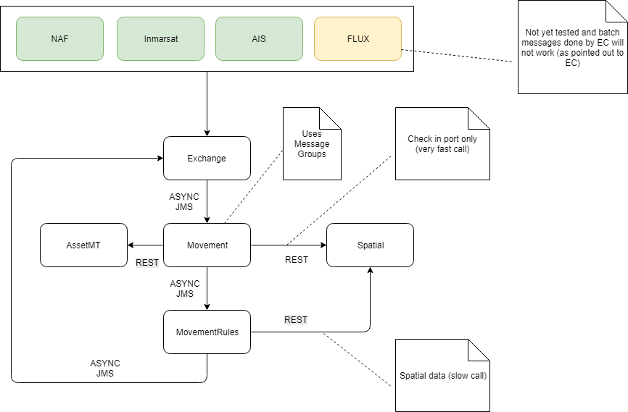
- All messages passing from Exchange and in the system are now asynchronous.
- The Movement Module now works with message groups (this means that we do parallel work on incoming positions, grouped by vessels).
- The retry/resend mechanism is using standard JMS settings and if for some reason something goes wrong these messages will end up the DLQ (Dead Letter Queue).
# | Activity | Queue | Producer | Consumer
1 | RECEIVE
1.1 | TL transfer position message
1.2 | Plugin transfer position message
1.3 | Exchange logs and transfer positions
2 | VALIDATE
2.1 | Movement Rules enrich positions for validation (synchronous)
2.2 | Movement enrich positions (synchronous)
2.3 | Movement enrich positions (synchronous)
2.4 | Movement
3 | RESPOND
3.1 | Movement Rules send the response to Exchange
3' | SAVE
3.2 | Movement Rules send the validated movement for persistence

