Union VMS - Big Picture
- About
- High level system diagram
- High level system diagram (Cloud ready)
- High level activity diagram
- Modules
- Glossary
- Flux TL and Flux FMC

About
In the context of their fishing activities, Member States send 4 kinds of messages to other Members States or to EC (represented as the XEU node):
- Position: fishing vessels coordinate for representation on a map
- Fishing Activities Report: declaration or notification of fishing vessels activities, including correction, cancellation or deletion. A report basically tells who, what, how, where, when… fishing activity is done
- Fishing Activities Query: request sent to a third party of activity details. Two kind of request exists: the history of activities of a vessel over a period of time or the activities for a specific trip.
- Sales Notes

High level system diagram
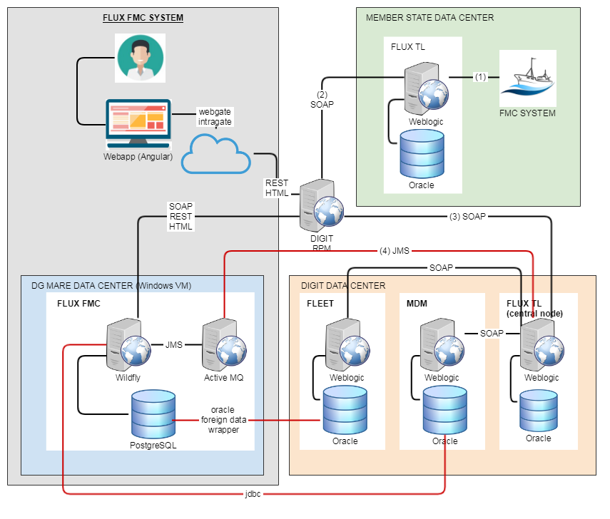

Communication with MS (via Flux TL):
- Member State FMC (Fishery Monitoring Center) collects and send their fishing activity data to the gateway "Flux TL" (Transportation Layer).
- Member State's "Flux TL" transmits message to the "Central Node" at EC (another Flux TL instance)
Each MS has its own instance of Flux TL that sends/receives messages to/from the Central Node (star architecture).
- Central Node (EC's Flux TL) transmits data to the recipient. In this case, recipient is "XEU".
Depending of the "data-flow" (information provided in the message), the Central Node transmits data to the correct system.
In this diagram, the systems are Flux FMC, Fleet or MDM - all connected to Flux TL.
Communication with EC system (In red are the elements incompatible with the cloud)
- Flux TL: message received from / sent to MS are via "Flux TL - Central Node": JMS for Fishing Activity report; SOAP for other reports
- FLEET: the local Vessel database of Flux FMC is synchronised with Fleet.
- MDM: the local reference database of Flux FMC is synchronised with MDM.
Due to the architecture of Flux TL, Flux FMC cannot fetch this like other MS (via the Central Node)

High level system diagram (Cloud ready)
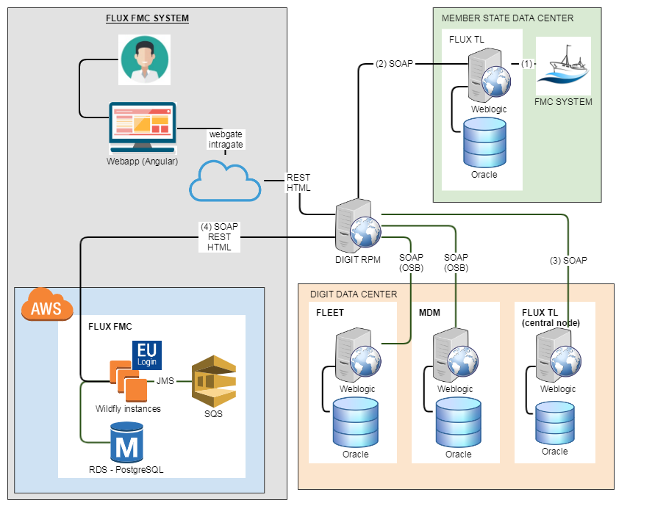

Changes for the Cloud:
- User authentication: USM (User Security Management) integrates EU Login for authentication of the users (public REST api)
- TL communication: protocol with Flux TL is SOAP exclusively (no JMS)
- FLEET/MDM communication: DB link are replaced by a REST api. EU Login (JWT) could be used (depends of those systems' architecture)

High level activity diagram
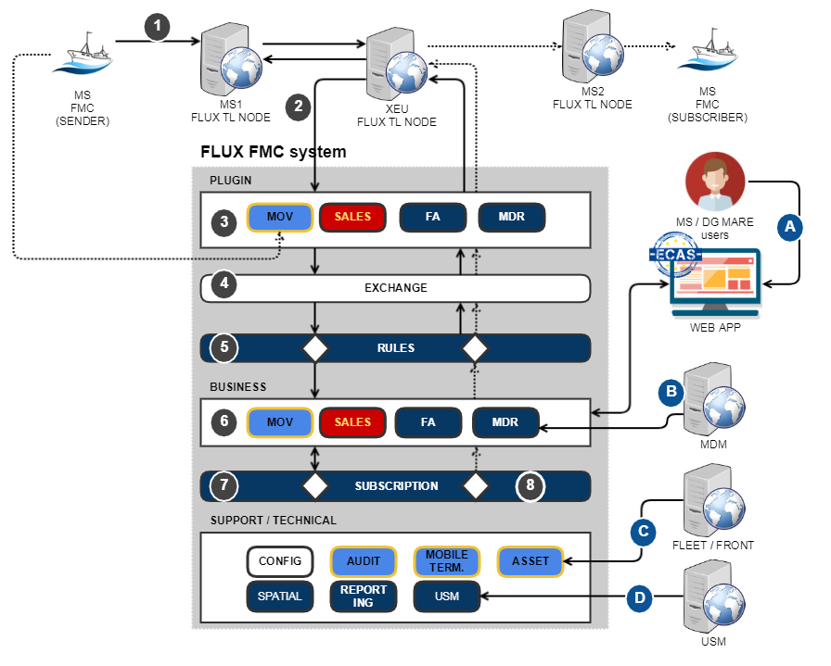

 | Activity | Description
1 | INITIAL REQUEST | MS FMC (Fisheries Monitoring Center) sends a request through its Flux Node.  A request is composed of: sender (FO); recipient (TO); data-flow (DF) and the message.  Four DF are possible, each one related to one of the four business module: MDR, FA, SALES and MOV.
2 | RECEPTION | Flux Central Node responds and forward request  EC Flux Central Node receives the request and respond (synchronously) according to the validity of the request.  Two responses are possible: OK (FO, TO, DF and certificate are valid), NOK otherwise (the content of the message is not checked).  The request is then forwarded to FLUX FMC system (some DFs are connected to other system).
3 | TRANSLATION | Plugin module receives request and translate it to its model.  Each business module has a plugin: FA, Sales, Mov and MDR
4 | LOGGING | Exchange module logs all communication and forward the request
5 | VALIDATION & RESPONSE | Rules module applies business rules and a response is sent to the sender. If the rules fail, the request stops.
6 | ACTION / PERSISTENCE | The business module performs the required action: persistence, response...
7 | SUBSCRIPTION | Subscription module has different roles and is invoked by the business layer:  FA Report: forward and/or send FA query for additional info.  FA Query: check if the response (FA report) is allowed (authorization)
8 | RESPONSE | For each subscription (if any), a new request is created and transmitted o the subscriber via the business module.
 | Additional component | Description
A | WEB APP | The Web application (or front-end) allows authorized users to manage Union VMS system.  At EC the web application required an ECAS authentication.
B | MDM | MDM is the DG MARE system to manage master (or reference) data. Union VMS has a cache mechanism of MDM using Flux TL.  At DG MARE, an internal synchronization must be put in place w/o going through Flux TL.
C | FLEET | Fleet is the DG MARE register of vessels.  At DG MARE, an internal synchronization must be put in place to populated the Assets database.
D | USM CENTRAL | At EC Flux FMC uses the central database of USM

Modules
 | Module | Description
1 | Plugin (x4) | Each major module have its plugin to communicate with Flux TL: Activity (JMS), Movement (WS), Sales (WS), MDR (WS)
2 | Exchange | Layer between Plugin and Rules. Role is to log incoming and outgoing traffic.
3 | MDR | Reference data: area, species, countries... It's a cache of the EU-MDM
4 | Activity | FA (Fishing Activities): Who fish what, where and how? (Vessel, Species, Area, Gear)
5 | Movements | "Real-time" vessel localisation (delay of max 2h)  Positional information and everything related to this.  Access to the enriched positional data, segments, tracks. This component is responsible to get the positional data other components need, enrich this data (calculate nearest port, country, in which area(s) it is located, segments, tracks etc.).
6 | Sales (x2) | Record the fish sales. A separate module fetches the exchange rate.
7 | Asset | Vessel register. At EC, Asset is synchronized with Fleet but no sync. system is available outside EC.  Basically a local vessel database including information on VMS device IDs, etc. (development started). Possibility to connect to an existing vessel register (which should expose a number of services).
8 | USM | Authentication and authorization module used by the front-end application and by the back-end to control node actions  USM configures USERS, ORGANIZATIONS and COMMUNICATION CHANNELS. (see requirements for details).  USM also include the configuration of "context or scenarios" which is actually access rights to the data (what data can a user see, what reports are available, etc.). A scenario is like a context in which the user is working. There is always one default scenario and there can be more scenarios. When a user switches scenario, his access rights on the data change (simply said, he only sees what he is allowed to see within the scenario). The scenario is mainly based on time period, vessel groups, areas.  Each and every call to a function or access to data much be checked and restricted according to the dynamic roles.
9 | Rules | Apply business rules on incoming/outgoing data flow (4 data-flow). About 700 business rules are applied using Drools library.
10 | Subscription | Possibility for a Flux node to subscribe to a data-flow event with additional condition (time, area, vessel, country...)  Subscription has 2 roles: forward message to subscriber node and validate permissions of incoming queries (in addition to rules)
11 | Reporting | Generate report related to a data flow using the web application (front-end).  Reports are based on selection parameters and with possible output in tabular, graphical and map view.
12 | Config | General configuration of the application.
13 | Audit | Log activities of the web application (front-end)
14 | Spatial | Library to compute distance, geographic location... used by Movement module. It allows the creation of the maps on the screen (including zoom, pan, identify, ...), select interactively what to show on the real-time map, add new layers, create user polygons, modify map symbology by user, possibility to export map as image or report, serving background images (OpenStreetMap) and thematic data (positions, segments, tracks).
15 | Mobile Terminal | Used by movement to enrich positions.
16 | Web | Front-end (WAR - Angular)

Glossary
COM | European Commission
EFCA | European Fisheries Control Agency
ERS | Electronic Reporting System
FLEET | DG MARE system to manage fishing vessel. Flux FMC synchronise (import) vessels from Fleet into Asset module.
FLUX | Fisheries Language for Universal Exchange
FLUX TL | Message Transportation Layer
FLUX FMC | Integrated system to exchange and view vessel positions, fishing activities and sales notes
MDR/MDM | Master Data Register / Master Data Management
RFMO | Regional Fisheries Management Organisation
SFPA | Sustainable Fisheries Partnership Agreement
UN/CEFACT | United Nations Centre for Trade Facilitation and Electronic Business
UN/FLUX | The FLUX standard under UN
VMS | Vessel Monitoring System
Subscribers | Parties allowed exchanging fishery related data with the system, such as Member States, RFMOs or third parties.  Subscribers are organisations as defined by the USM module and have one or more end-points
End-point or Node | The definition of the connection for exchanging one more data flows. Details about the connection, the format and type of data are described in the communication channel. This parameter is used to define the dataflow (in case of FLUX this is the DF) and so the plugin to be used.
USM | Module that manages users, roles and permissions. For subscriptions the following information is relevant: Organisation, End-Point and Communication channel/dataflow.
Activity (Fishing Activity related Messages) | A message is sent from one node to another single node and can contains:  - One FA Query  - One or several FA Report(s), typically related to one Vessel. When relevant, the FA Report contains the reference of the related FA Query.
Position (Vessel Position related Messages) | One or several Positions related to one Vessel
Sales (Sales related Messages) | - One Sales Query  - One or several Sales reports
Report or FA Report (Fishing Activity related Report) | Refers to a FLUXFAReportMessage. When relevant, a report contains the unique reference ID of the original report (for cancellation/correction/deletion report).
Query or FA Query (Fishing Activity related Query) | Refers to a FLUXFAQueryMessage. A Query request activities for one trip or for one Vessel over a period of time (up to 3 years - configurable).
Position | Refers to a FLUXVesselPositionMessage
Response | Refers to a FLUXReponseMessage. A response always contains the reference ID of the related query/report message. Currently there is no response message defined for a vessel position message. It is however being discussed and may exist in the future. Currently the response to a sales report message is a specific FLUXSalesResponseMessage. In the future version (July 2019) the generic FLUXResponseMessage will also be used for sales messages and queries as well.
Activity | Report containing information about the fishing activity declaration or notification. There are about 15 different activities defined in the FA domain.
Position | Refers to the coordinate(s) of a vessels at a certain time
Vessel/Asset | Fishing vessel identified with one or several identifiers (e.g. CFR, ICCAT, IRCS, UVI...).
Logbook | Refers to all activity reports of one Vessel for one trip (usually starting with a "departure" and ending with a "return to port" or "landing" activity).
Consolidated report | Last version of a report. Non-consolidated means all versions of a report including the original, corrections...
Rule | All incoming and outgoing messages are validated against "business rules", defined in implementation documents. There are implementation documents for each domain and context in which it is used. For the Fishing activity domain in EU context, the rules are defined in the "FLUX Fishing Activity Implementation Document in the EU". There are implementation documents existing (eg. for sales or vessel position domains in EU or being drafted (fishing activities in NEAFC/international). Currently only the business rules for fishing activity and sales (around 700) have been implemented in the system.

Flux TL and Flux FMC
